Software Requirements Specification

for

“NextGen Game Store”

Version 1.0

Prepared by Suliță Cosmin

March 20, 2017

Table of Contents

Table of Contents ii

1. Introduction 1

1.1 Purpose 1

1.2 Product Scope 1

1.3 References 1

2. Overall Description 2

2.1 Product Perspective 2

2.2 Product Function 2

2.3 User Classes and Characteristics 3

2.4 Operating Environment 3

2.5 Design and Implementation Constraints 3

2.6 User Documentation 3

2.7 Assumptions and Dependencies 3

3. External Interface Requirements 4

3.1 User Interfaces 4

3.2 Hardware Interfaces 6

3.3 Software Interfaces 6

3.4 Communications Interfaces 6

4. System Features 7

4.1 Account Operations 7

4.2 Admin Operations 7

4.3 Search Product 8

4.4 Add to Shopping Cart 8

4.5 Delete from Shopping Cart 8

4.6 Checkout 8

5. Other Nonfunctional Requirements 9

5.1 Performance Requirements 9

5.2 Safety Requirements 9

5.3 Security Requirements 9

5.4 Software Quality Attributes 9

6. Other Requirements 9

# Introduction

## Purpose

*The purpose of this document is to define the system requirements for the “NextGen” online video games store. It will explain the purpose and features of the store, it’s interfaces, what it will do, the constraints under which it must operate and how the store will interact with the users.*

## Product Scope

*The objective of this project is to create and implement an online video games store website. The website will be used by anyone looking for video games or gaming accesories for a specific platform, such as Playstation, Xbox or PC. The website will allow users to create and maintain an individual account and search the store database for games or gaming accessories. The website’s administrators will be able to add/remove products and modify prices. The website will be connected to a relational database containing a list of products related data, and user data.*

## References

*IEEE. IEEE Std 830-IEEE Recommended Practice for Software Requirements*

# Overall Description

## Product Perspective



## Product Function

* *User/Admin Login*
* *New user registration*
* *Add/Remove/Edit product (admin only)*
* *Browse store and add products to the shopping cart*
* *Buy product*
* *Manage payment*

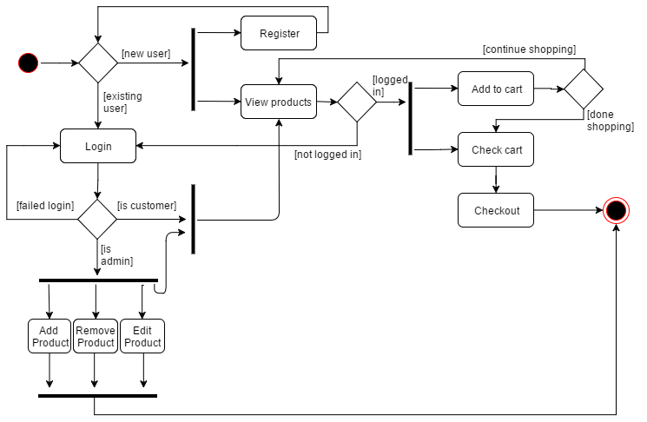

## User Classes and Characteristics

The application users will be the store’s employees which will have administrator privileges and citizens which will have regular member accounts. Users of the website must know how to navigate a website.

## Operating Environment

The “NextGen Game Store” will require users to have access to a web browser on their personal computer such as Google Chrome (Version 56.0.2924 or later), Mozilla Firefox (Version 50 or later) or Opera (Version 43.0.2 or later).

## Design and Implementation Constraints

Creating a user interface which is both effective and easily navigable will pose a difficult challenge. Other constraints such as a weak web-host and slow internet browsers (“Internet Explorer”) are also worth considering. “NextGen Game Store” is meant to be quick and responsive, so each feature must be designed and implemented with efficiency in mind.

*Backend language: Java*

*Frontend: HTML, CSS, JavaScript*

*Framework: Bootstrap / Spring*

## User Documentation

NA

## Assumptions and Dependencies

The web application assumes that the user has a computer with an Internet connection and a web browser to access “NextGen Game Store”. The system may not behave correctly when used with internet browsers other than Firefox (Version 50 or later), Google Chrome (Version 56.0.2924 or later) or Opera (Version 43.0.2 or later).

# External Interface Requirements

## User Interfaces

*The layout should be as follows:*

* *The header which displays:* 
  + - *the logo*
    - *a cover photo*
    - *the currently logged user (for logged users) / login button (for visitors)*
    - *the “Logout” and “Edit Account” menu*
  + *The body, which displays* 
    - *the menu containing product categories and the shopping cart*
    - *the content of the selected category (if no prior category was selected the content will be just the welcome page)*
    - *Buy / Add to cart / View Details buttons for each product*
  + *The footer, which displays* 
    - *contact*
    - *copyright*

**

*There will be three different user interfaces that will accompany this website: one for the visitors of the site, one for the registered clients and one for the administrators.*

* *Simple visitors will be able to only browse the products and view the games/accessories currently availible for sale.*
* *The administrators will be able to add or remove products and also change the prices of the products.*
* *The registered clients shall have all the features that simple visitors have. Additionally they will have the possibility to add items in their shopping carts, and perform the purchase.*

**

**

**

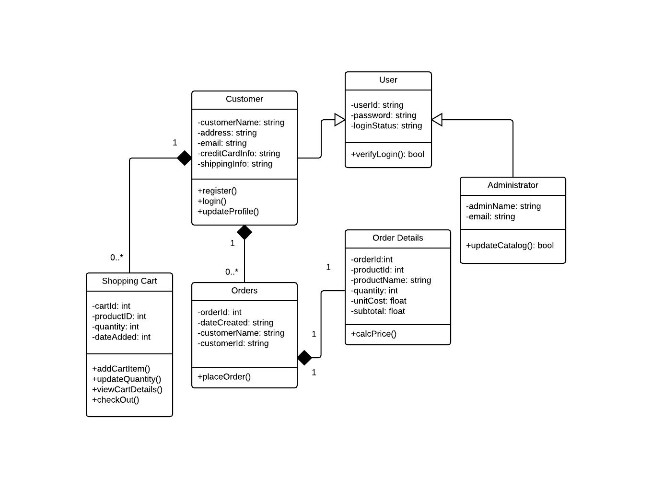

## Hardware Interfaces

NA

## Software Interfaces

*The application is connected to a database (MySQL). The database will communicate with the server, and the server will send the information to the client application. The information will consist of data regarding the quantity and price of products available for sale in the inventory.*

## Communications Interfaces

HTTP will be the communication protocol that “NextGen Game Store” will use.

# System Features

## Account Operations

### Account Registration

*Functional Requirements*

* *The system shall allow a non-registered user to create a secure account.*
* *The system shall require the following information from the user:*
  1. *First name (max 20 chars)*
  2. *Last name (max 20 chars)*
  3. *Username (max 20 chars)*
  4. *Password*
* *The system shall confirm the username and password are accepted*
* *The system shall store the information in the database.*

### Account Login

*Functional Requirements*

* *The system shall allow a registered user to log-in to their account.*
* *The system shall require a username and password from the user.*
* *The system will verify the username and password, and the user will be considered “logged-in”.*
* *All fields are to be written in the text boxes offered by the login interface.*

### Account Logout

*Functional Requirements*

* *The system shall allow the registered and logged-in user to exit his/her account, so that access to operations requiring a user to be logged in are now disabled.*

## Admin Operations

### Edit Product

*Functional Requirements*

* *The system shall allow a logged-in admin to modify a product.*
* *The system shall display all the information regarding that product with the possibility of modifying its description and price.*

### Add Product

*Functional Requirements*

* *The system shall allow a logged-in admin to add a new product.*
* *The system shall upload the new product information into the database.*

### Remove Product

*Functional Requirements*

* *The system shall allow a logged-in admin to remove a product.*
* *The system shall update the database and remove the specified product.*

## Search Product

*Functional Requirements*

* *The system shall allow a logged-in client or a simple visitor to search for products by name.*
* *The system shall require the name of the product.*
* *The search results will include a thumbnail of the product along with its description and price.*

## Add to Shopping Cart

*Functional Requirements*

* *The system shall allow a registered and logged-in user to temporarily save products that are being considered for purchase into a list associated with their account.*
* *When viewing the shopping cart list, the system shall display the total price of the products in the cart.*

## Delete from Shopping Cart

*Functional Requirements*

* *The system shall allow a registered and logged-in user to remove any unwanted products from their shopping cart.*
* *The system shall provide the user a way to select one of the products in his/her cart for deletion.*
* *After the user has indicated the particular product to be deleted from their shopping cart, the stored list representing the shopping cart should be updated, and the view should be updated to show only the products remaining in the cart.*

## Checkout

*Functional Requirements*

* *The system shall allow a registered and logged-in user to purchase products*

*that are in their shopping cart.*

* *The user will receive a confirmation number.*
* *The products (names, prices and quantities) will be displayed to the screen.*

# Other Nonfunctional Requirements

## Performance Requirements

*The product shall take initial load time depending on the internet connection strength which also depends on the media-device from which the product is run. The performance shall depend upon hardware components of the client/customer.*

## Safety Requirements

*Information transmission should be securely transmitted to the server without any changes in information.*

## Security Requirements

*The system shall use secure sockets in all transactions that include any confidential customer information. The system shall confirm all transactions with the customer’s web browser.*

## Software Quality Attributes

*Availability: the system is available 24 hours a day.*

*Portability: a user can log in to the system at any time.*

*Reliability: the system can be used by multiple users concurrently.*

*Coding rules used for the implementation:*

*Rule 1(required) Source code shall only use /* … */ style comments.*

*Rule 2(advisory) No identifier name should be reused.*

*Rule 3(required) All automatic variables shall have been assigned a value before being used*

*Rule 4(advisory) The increment (++) and decrement (--) operators should not be mixed with*

*other operators in an expression*

*Rule 5(advisory) Write only one declaration per line*

*Rule 6(advisory) Use meaningful names for variables*

*Rule 7(required) All if … else if constructs shall be terminated with an else clause.*

*Rule 8(required) All constants must be declared with capital letters and underline between*

*words*

*Rule 9(required) The operands of a logical && or || shall be primary-expressions.*

*Rule 10(required) There shall be no unreachable code.*

# Other Requirements

*NA*